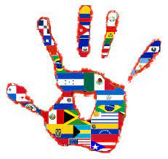

**International Festival Night**

**Wednesday, October 18th 5:30-7:30pm**

**Riverwood Cafeteria/Gym**

Please join us to celebrate our diverse school.

Wear traditional clothing from your country. If you would like to share information about your country/culture, please return this paper:

______ My family would love to set up (5:00pm) a table and showcase some great things about our culture! Please let us know by Monday, Oct. 16th.

________ ¡A mi familia le encantaría montar (5:00 pm) una mesa y mostrar algunas cosas geniales sobre nuestra cultura! Por favor, háganoslo saber antes del **lunes 16octubre**

Child’s Name/niño Teacher/Maestro

Thank you, ESL Teachers,

Gina Hawkins, Varonia Reed, and Francia Ortiz